

**SMALL OPERATING SYSTEM**

**(SOS)**





PREPARED BY

MOHAMMED ABDULWAHAB HEGAZY

PREPARED BY

MOHAMMED ABDULWAHAB HEGAZY

1. High Level Design 3
   1. System Architecture 3
      1. Layered Architecture 3
      2. System modules 4
2. State Machine diagram for SOS module 5
3. Sequence Diagrams for Application Logic 6
4. Class Diagram for SOS Module 8
5. **High Level Design**
   1. **System Architecture**
      1. **Layered Architecture**

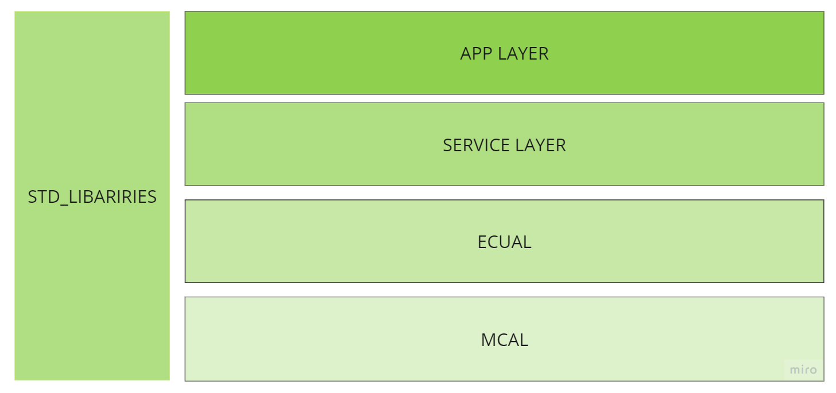

* + 1. **System modules**

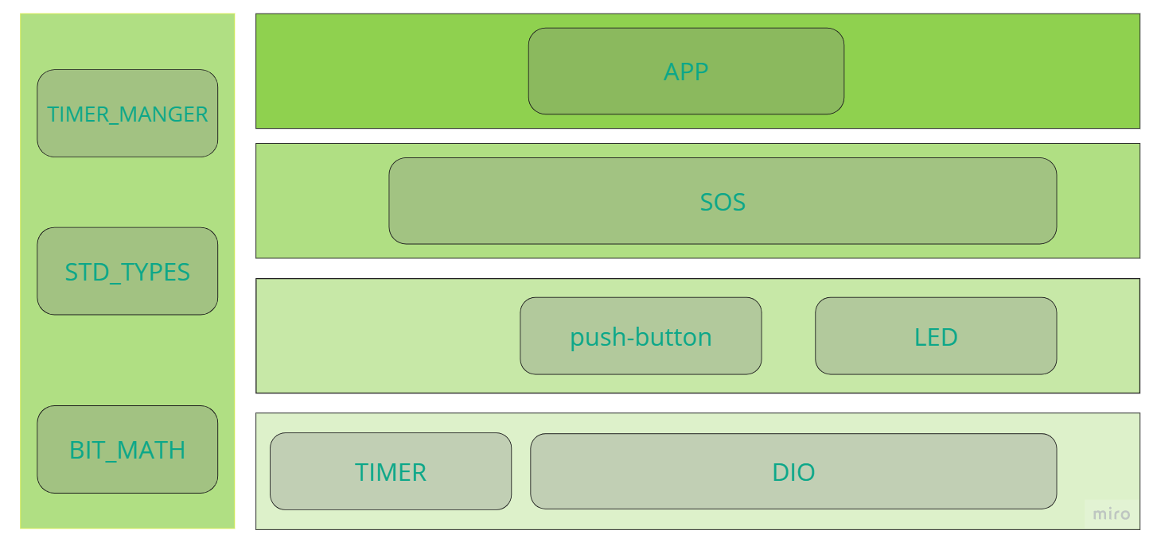

1. **State Machine diagram for SOS module**

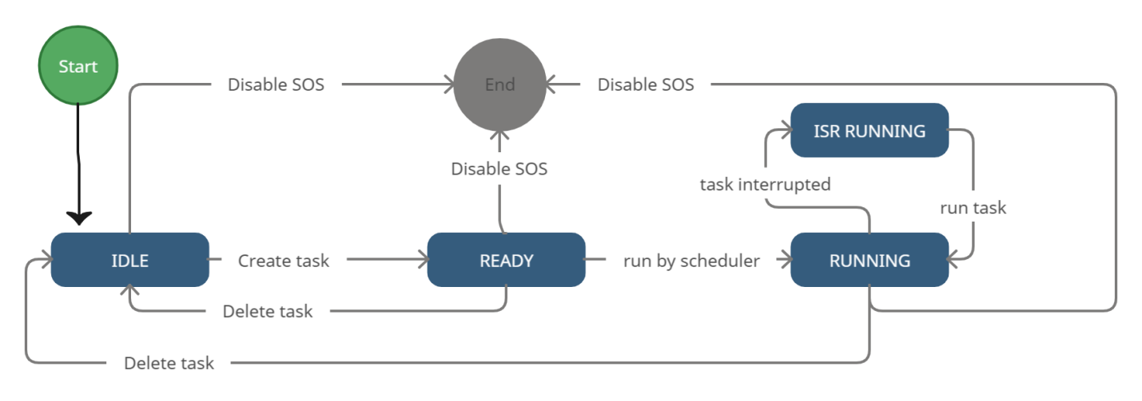

1. 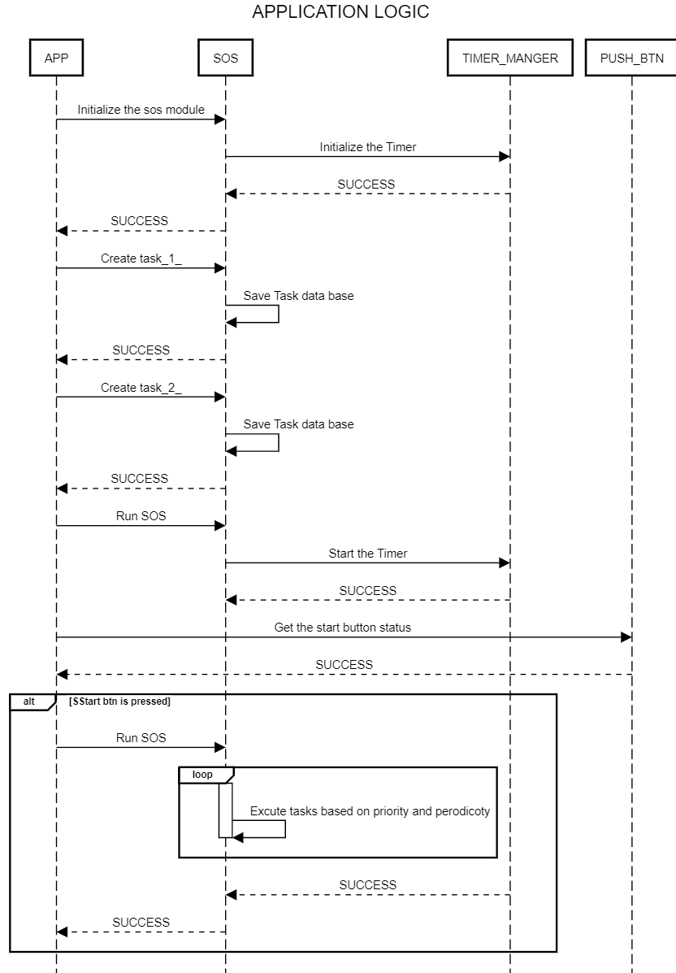**Sequence Diagrams for Application Logic**

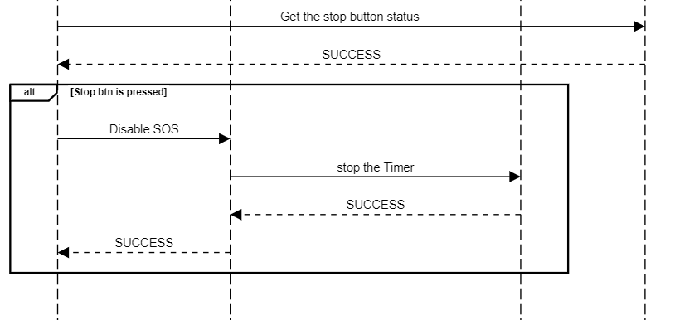

1. **Class Diagram for SOS Module**

